Interactive Arts and Sciences: Web Media Production

Final Webpage

Student Name: Soyeon Kang

Student Number: 6588420

Course Code: IASC-STAC 1P02 D02 FW 2018

Instructor: Tom Brown

Date Submitted: Nov 29, 2018

As you have seen in previous assignments, I like Marvel. So I want to make a page about Marvel in this final project. My page is about Marvel Cinematic Universe (MCU), the most important element in Marvel movies. This page provides a simple concept of MCU so that you can understand them easily.

**Color Theory:**

When you think about Marvel, the red images come to your mind. Even if you look at the Marvel logo, the red frame comes first in your eyes. I used a ‘triadic color scheme’ on the color wheel based on red. I got the result as the picture shown below.

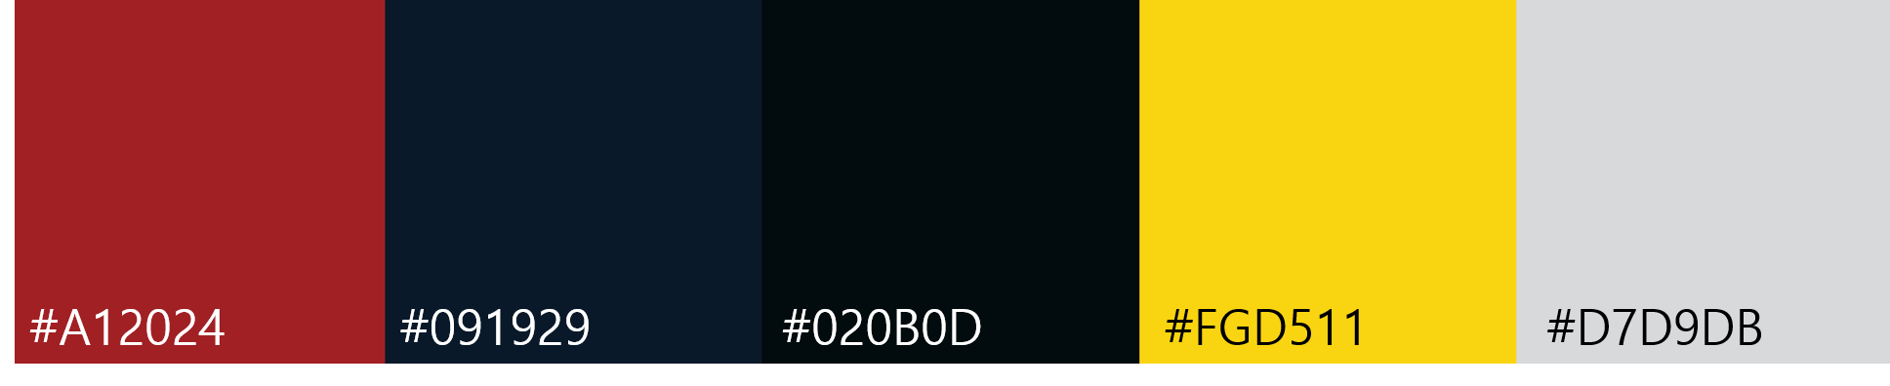

**Header**

Header is a part where logo of the page and the name is entered. The logo representing the MCU is placed in the center based on the content. You can infer the contents of this page as soon as you enter the page.

**Navigation**

There are four menus: Home, About, Phase, and Photo. I set the background color to red, and the selected menu is blue so it shows which menu the page user is looking at. Also, the ‘hover’ function changes the color of the menu when the mouse is placed on the menu.

**Footer**

I have added Marvel Instagram, Facebook, Youtube and the information about the page creator at the bottom of the page. Clicking on each icon will link to those pages. Footer gave the contrast by setting background to blue as opposed to the background color of navigation. In addition, one of the color schemes, yellow, is set to font color so that the contents of the footer stand out.

**Main Content**

* Contrast: I contrast to font size. Heading tags maintain with text elements using a difference in their sizes. To draw users’ attention, I keep its size significantly larger than the surrounding elements.
* Repetition: I used repetition of font type. Navigation, the content that I want to emphasize and footer I used ‘Sans’ fonts that are useful on the web. In the aboutpage.html, which has many contents to read, the body text used ‘Serif’ font to increase readability and reduce fatigue.

In photopage.html, photos of certain size are repeatedly arranged, giving a feeling of being organized.

* Alignment: There is some text in aboutpage.html. I used left alignment to look neat and easy to read.
* Proximity: I grouped related items together so that related items are seen as one group. Empty space between elements serves the purpose of visually separating the header, navigation and content areas. As you can see in aboutpage.html, I have enough space to read long texts. Further, there is a noticeable gap between the two blocks of text indicating a dissociation.

**Other**

* I used an ‘anchor’ so that users could go up whenever they read the contents.
* photopage.html uses ‘Lightbox’ to flip the picture left and right and it can be easily opened and closed.